– Total loan applications
SELECT
COUNT(id) AS Total_Loan_Applications
FROM bank_loan_data

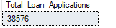

SELECT
COUNT(id) AS MTD_Total_Loan_Applications
FROM bank_loan_data
WHERE MONTH(issue_date) = 12
AND YEAR(issue_date) = 2021
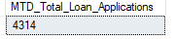

SELECT
COUNT(id) AS PMTD_Total_Loan_Applications
FROM bank_loan_data
WHERE MONTH(issue_date) = 11 AND
YEAR(issue_date) = 2021
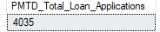

– Total funded amounts
SELECT
SUM(loan_amount) AS Total_Funded_Amount
FROM bank_loan_data
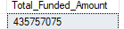

SELECT
SUM(loan_amount) AS Total_Funded_Amount
FROM bank_loan_data
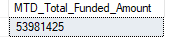

SELECT
SUM(loan_amount) AS PMTD_Total_Funded_Amount
FROM bank_loan_data
WHERE MONTH(issue_date) = 11 AND
YEAR(issue_date) = 2021
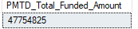

– Total amount received
SELECT
SUM(total_payment) AS Total_Amount_Received
FROM bank_loan_data
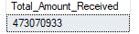

SELECT
SUM(total_payment) AS MTD_Total_Amount_Received
FROM bank_loan_data
WHERE MONTH(issue_date) = 12 AND
YEAR(issue_date) = 2021
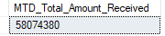

SELECT
SUM(total_payment) AS PMTD_Total_Amount_Received
FROM bank_loan_data
WHERE MONTH(issue_date) = 11 AND
YEAR(issue_date) = 2021
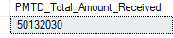

– Average Interest Rate

SELECT
ROUND(AVG(int_rate) * 100, 4) AS Avg_Interest_Rate
FROM bank_loan_data
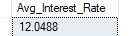

SELECT
ROUND(AVG(int_rate) * 100, 4) AS MTD_Avg_Interest_Rate
FROM bank_loan_data
WHERE MONTH(issue_date) = 12 AND
YEAR(issue_date) = 2021
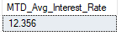

SELECT
ROUND(AVG(int_rate) * 100, 4) AS PMTD_Avg_Interest_Rate
FROM bank_loan_data
WHERE MONTH(issue_date) = 11 AND
YEAR(issue_date) = 2021
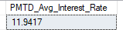

– Average Debt-to-Income Ratio (DTI)
SELECT
ROUND(AVG(dti) * 100, 2) AS Avg_DTI
FROM bank_loan_data
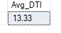
SELECT
ROUND(AVG(dti) * 100, 2) AS MTD_Avg_DTI
FROM bank_loan_data
WHERE MONTH(issue_date) = 12 AND
YEAR(issue_date) = 2021
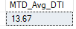

SELECT
ROUND(AVG(dti) * 100, 2) AS PMTD_Avg_DTI
FROM bank_loan_data
WHERE MONTH(issue_date) = 11 AND
YEAR(issue_date) = 2021
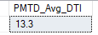

– Good Loan v Bad Loan KPI’s

– Check loan status
SELECT
loan_status
FROM bank_loan_data

-- Good Loan Application Percentage
SELECT
(COUNT(
CASE WHEN loan_status = 'Fully Paid' OR
loan_status = 'Current'
THEN id
END
) * 100) / COUNT(id) AS Good_Loan_Percentage
FROM bank_loan_data
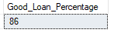

-- Good Loan Application
SELECT
COUNT(id) AS Good_Loan_Applications_Number
FROM bank_loan_data
WHERE loan_status = 'Fully Paid' OR
loan_status = 'Current'

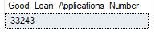

-- Good Loan Funded Amount
SELECT
SUM(loan_amount) AS Good_Loan_Funded_Amount
FROM bank_loan_data
WHERE loan_status = 'Fully Paid' OR
loan_status = 'Current'

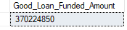

-- Good Loan Total Received Amount
SELECT
SUM(total_payment) AS Good_Loan_Total_Received_Amount
FROM bank_loan_data
WHERE loan_status IN('Fully Paid', 'Current')
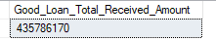

-- Bad Loan Application Percentage
SELECT
(COUNT(
CASE WHEN loan_status = 'Charged Off'
THEN id
END
) * 100.0) / COUNT(id) AS Bad_Loan_Percentage
FROM bank_loan_data
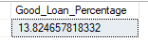

-- Bad Loan Application
SELECT
COUNT(id) AS Bad_Loan_Applications_Number
FROM bank_loan_data
WHERE loan_status = 'Charged Off'
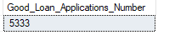

-- Bad Loan Funded Amount
SELECT
SUM(loan_amount) AS Bad_Loan_Funded_Amount
FROM bank_loan_data
WHERE loan_status = 'Charged Off'
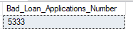

-- Bad Loan Funded Amount
SELECT
SUM(loan_amount) AS Bad_Loan_Funded_Amount
FROM bank_loan_data
WHERE loan_status = 'Charged Off'

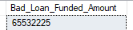
-- Bad Loan Total Received Amount
SELECT
SUM(total_payment) AS Bad_Loan_Total_Received_Amount
FROM bank_loan_data
WHERE loan_status = 'Charged Off'
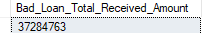

– Good Loan v Bad Loan KPI’s
SELECT
loan_status,
COUNT(id) AS Total_Loan_Applications,
SUM(total_payment) AS Total_Amount_Payment,
SUM(loan_amount) AS Total_Funded_Amount,
AVG(int_rate * 100) AS Interest_Rate,
AVG(dti * 100) AS DTI
FROM bank_loan_data
GROUP BY loan_status
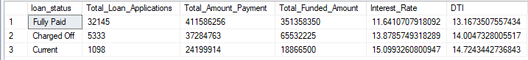

SELECT
loan_status,
SUM(total_payment) AS MTD_Total_Amount_Payment,
SUM(loan_amount) AS MTD_Total_Funded_Amount
FROM bank_loan_data
WHERE MONTH(issue_date) = 12
GROUP BY loan_status
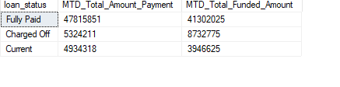
SELECT
loan_status,
SUM(total_payment) AS PMTD_Total_Amount_Payment,
SUM(loan_amount) AS PMTD_Total_Funded_Amount
FROM bank_loan_data
WHERE MONTH(issue_date) = 11
GROUP BY loan_status
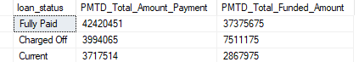
– Monthly Trends by Issue Date
SELECT
MONTH(issue_date) AS Month_Number,
DATENAME(MONTH, issue_date) AS Month_Name,
COUNT(id) AS Total_Loan_Applications,
SUM(loan_amount) AS Total_Funded_Amount,
SUM(total_payment) AS Total_Amount_Received
FROM bank_loan_data
GROUP BY MONTH(issue_date),
DATENAME(MONTH, issue_date)
ORDER BY MONTH(issue_date)
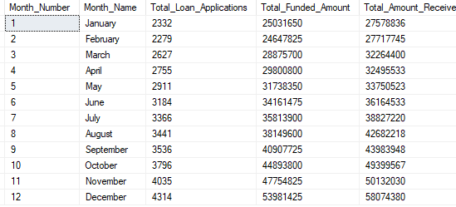

-- Regional Analysis by State
-- Regional Analysis by State
SELECT
address_state AS Address,
COUNT(id) AS Total_Loan_Applications,
SUM(loan_amount) AS Total_Funded_Amount,
SUM(total_payment) AS Total_Amount_Received
FROM bank_loan_data
GROUP BY address_state
ORDER BY COUNT(id) DESC
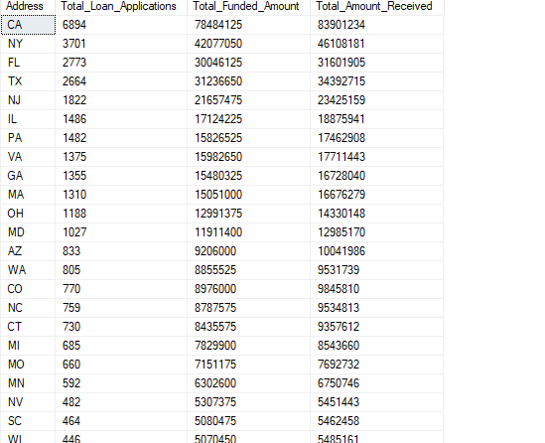

-- Loan Term Analysis
SELECT
term AS Term,
COUNT(id) AS Total_Loan_Applications,
SUM(loan_amount) AS Total_Funded_Amount,
SUM(total_payment) AS Total_Amount_Received
FROM bank_loan_data
GROUP BY term
ORDER BY term
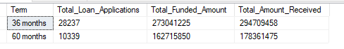

-- Employee Length Analysis
SELECT
emp_length AS Employee_Length,
COUNT(id) AS Total_Loan_Applications,
SUM(loan_amount) AS Total_Funded_Amount,
SUM(total_payment) AS Total_Amount_Received
FROM bank_loan_data
GROUP BY emp_length
ORDER BY emp_length
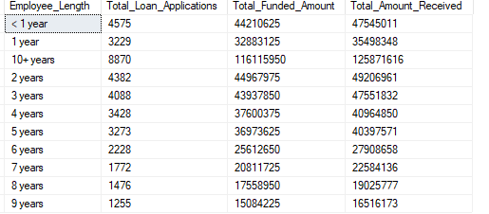

-- Loan Purpose Breakdown
SELECT
purpose AS Purpose_of_Loan,
COUNT(id) AS Total_Loan_Applications,
SUM(loan_amount) AS Total_Funded_Amount,
SUM(total_payment) AS Total_Amount_Received
FROM bank_loan_data
GROUP BY purpose
ORDER BY COUNT(id) DESC
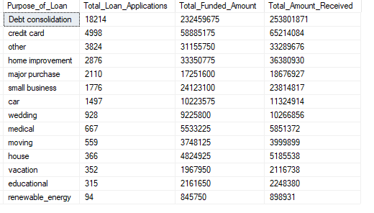

-- Home Ownership Analysis
SELECT
home_ownership AS Home_Owners,
COUNT(id) AS Total_Loan_Applications,
SUM(loan_amount) AS Total_Funded_Amount,
SUM(total_payment) AS Total_Amount_Received
FROM bank_loan_data
GROUP BY home_ownership
ORDER BY COUNT(id) DESC
